Test Case: runTestMultipleTimes
Step 1 - Enter username and password and click to button Enter : Credentials Entered
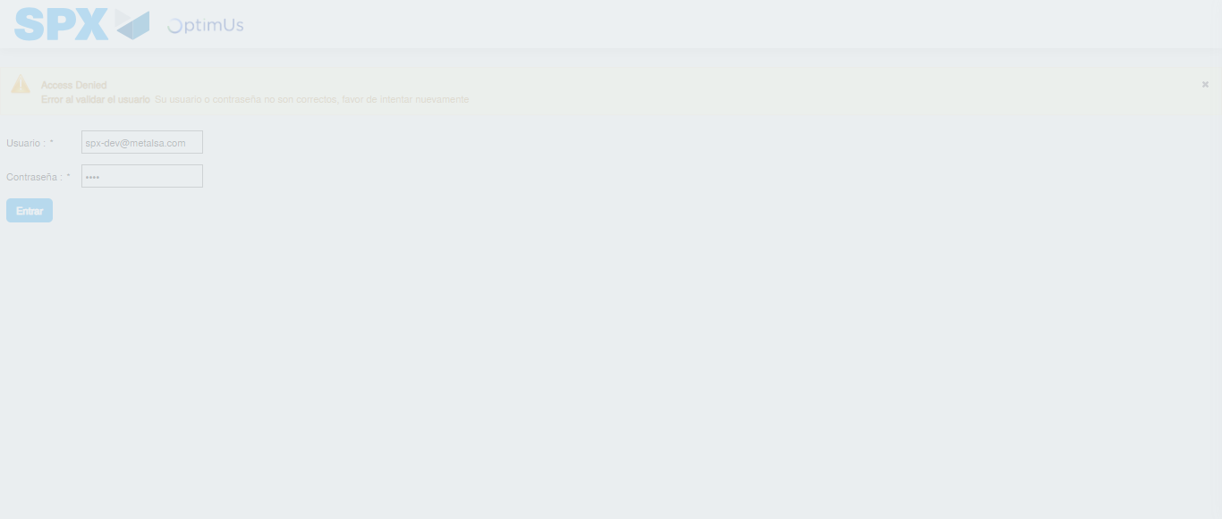Image file-name: QC_Testing-runTestMultipleTimes-dic. 04 2025, 03 59 20 p. m.

Step 2 - Select to UEN and Access to Articulos por Procesar: UEN Correctly selected and Correct access
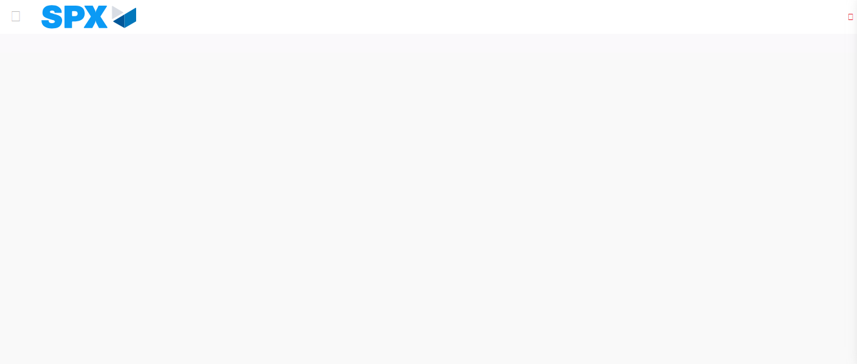Image file-name: QC_Testing-runTestMultipleTimes-dic. 04 2025, 03 59 29 p. m.

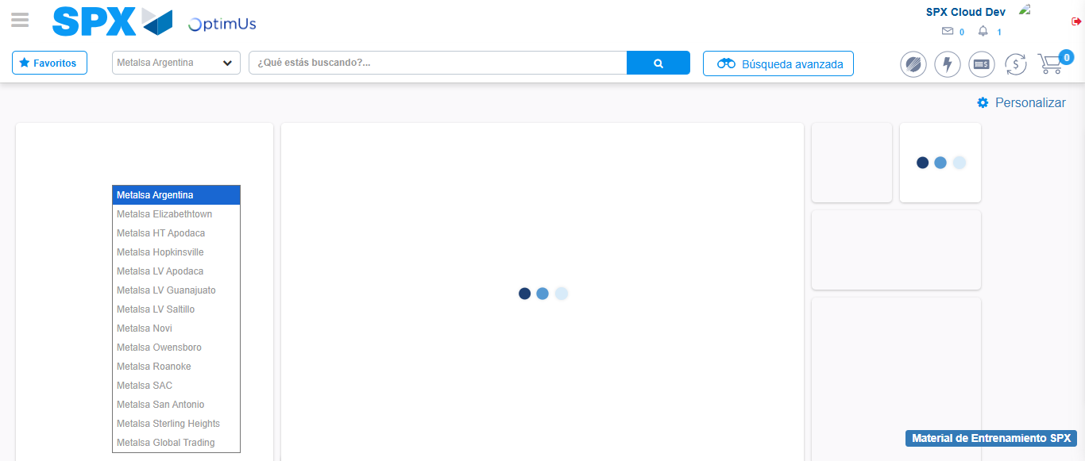Image file-name: QC_Testing-runTestMultipleTimes-dic. 04 2025, 03 59 30 p. m.

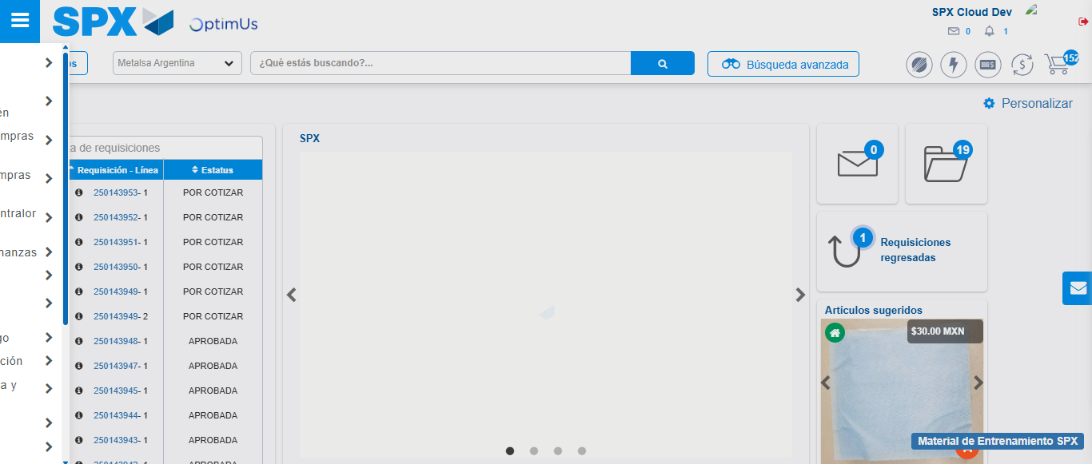Image file-name: QC_Testing-runTestMultipleTimes-dic. 04 2025, 03 59 31 p. m.

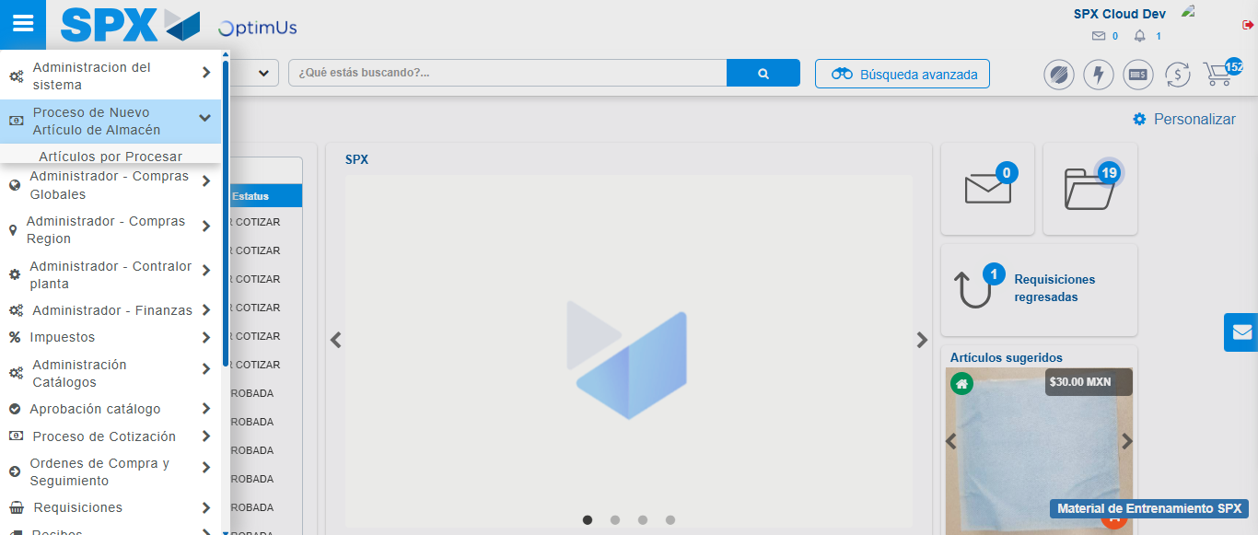Image file-name: QC_Testing-runTestMultipleTimes-dic. 04 2025, 03 59 32 p. m.

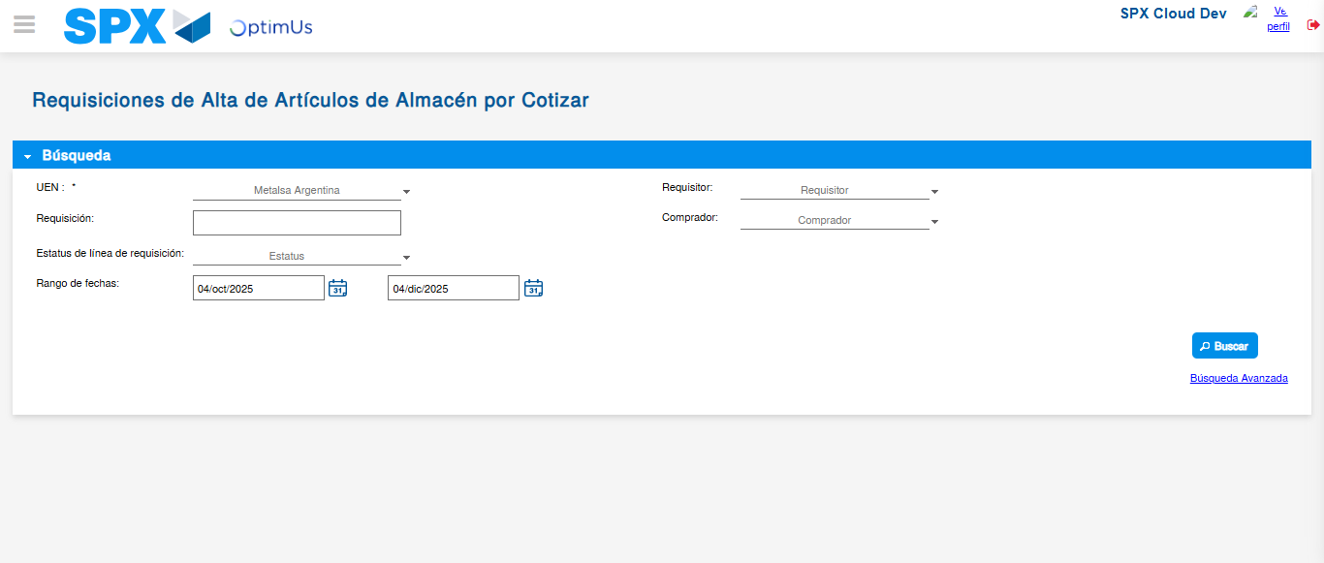Image file-name: QC_Testing-runTestMultipleTimes-dic. 04 2025, 03 59 35 p. m.

Step 3 - Validate search fields: Validated fields
Image file-name: QC_Testing-runTestMultipleTimes-dic. 04 2025, 03 59 36 p. m.

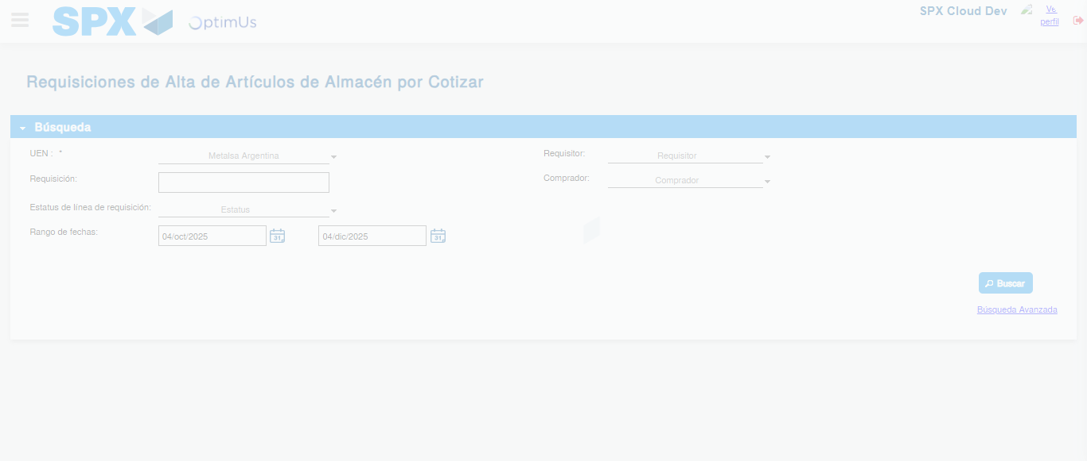Image file-name: QC_Testing-runTestMultipleTimes-dic. 04 2025, 03 59 40 p. m.

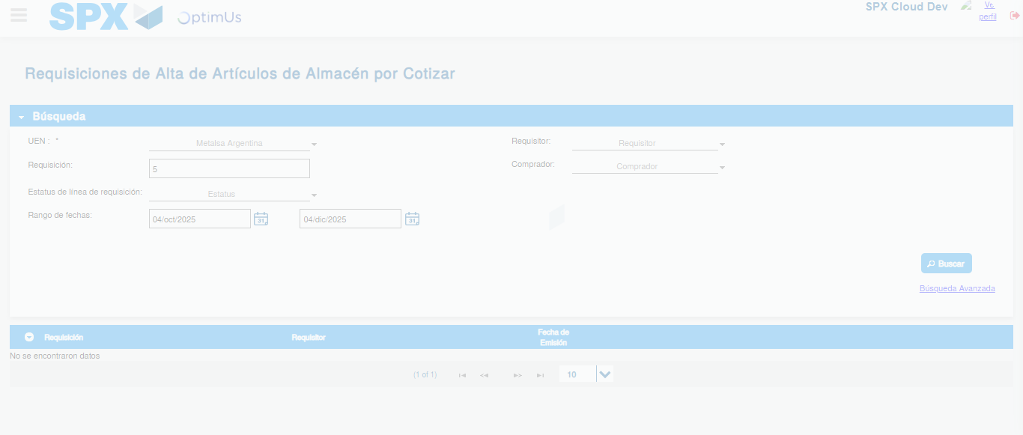Image file-name: QC_Testing-runTestMultipleTimes-dic. 04 2025, 03 59 58 p. m.

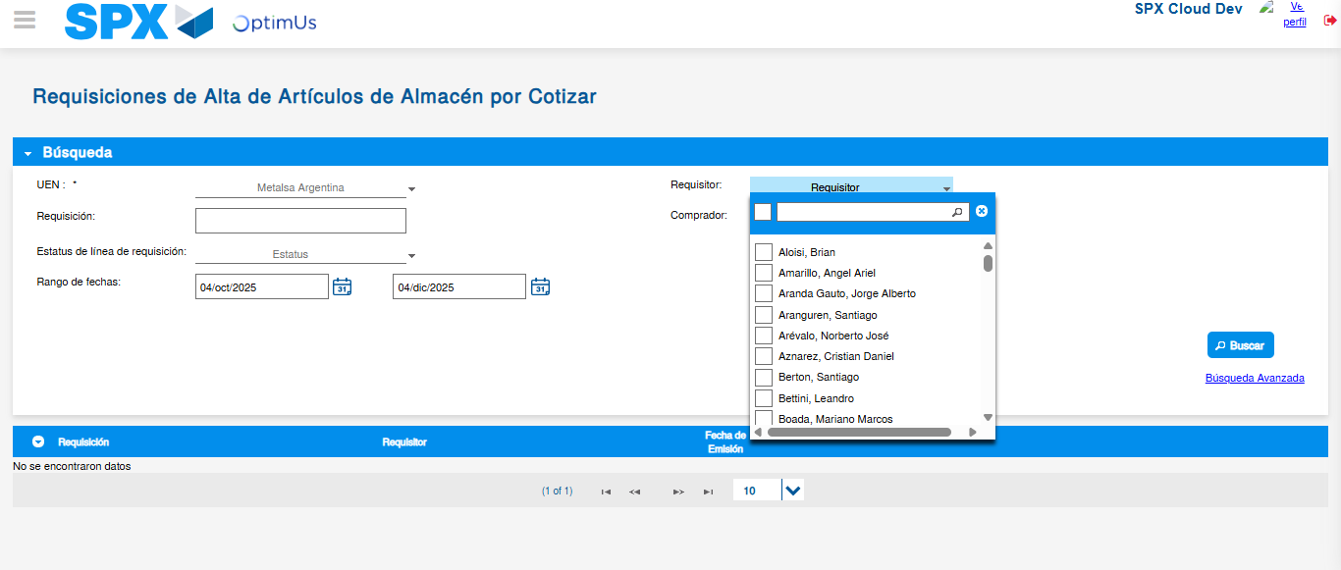Image file-name: QC_Testing-runTestMultipleTimes-dic. 04 2025, 04 00 17 p. m.

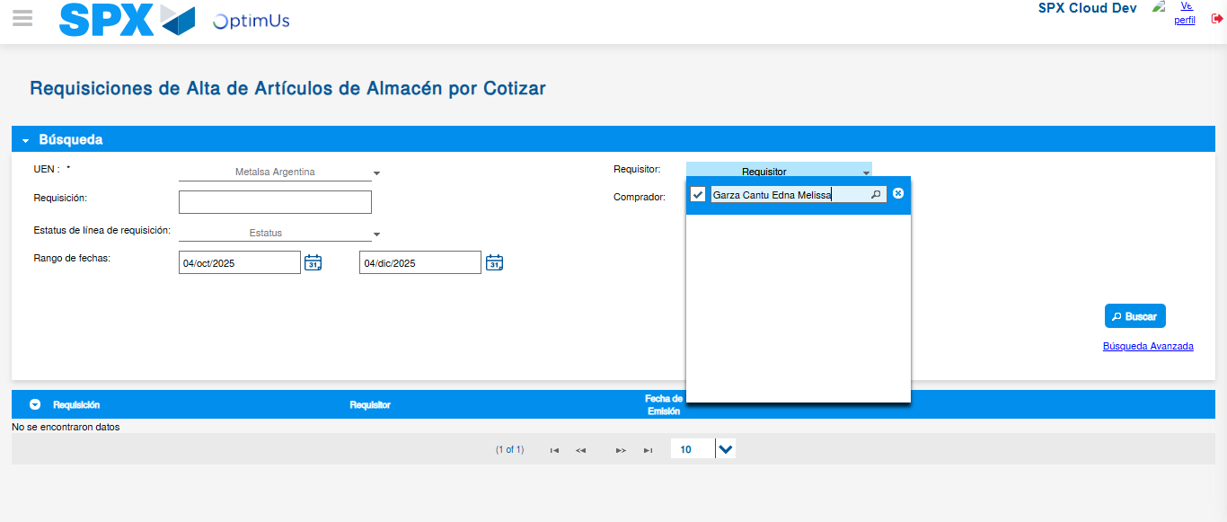Image file-name: QC_Testing-runTestMultipleTimes-dic. 04 2025, 04 00 18 p. m.

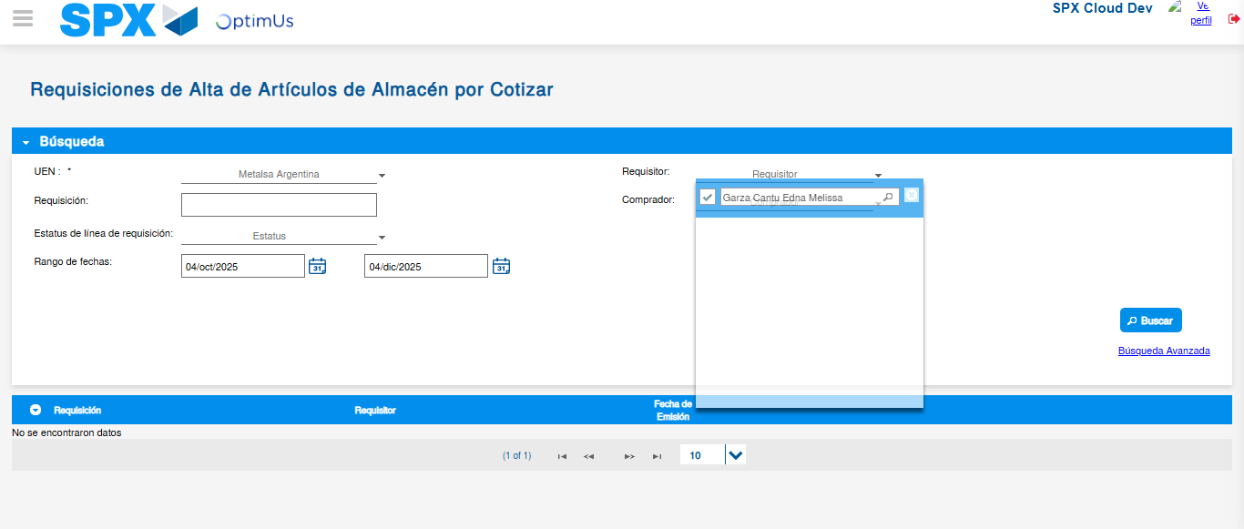Image file-name: QC_Testing-runTestMultipleTimes-dic. 04 2025, 04 00 43 p. m.

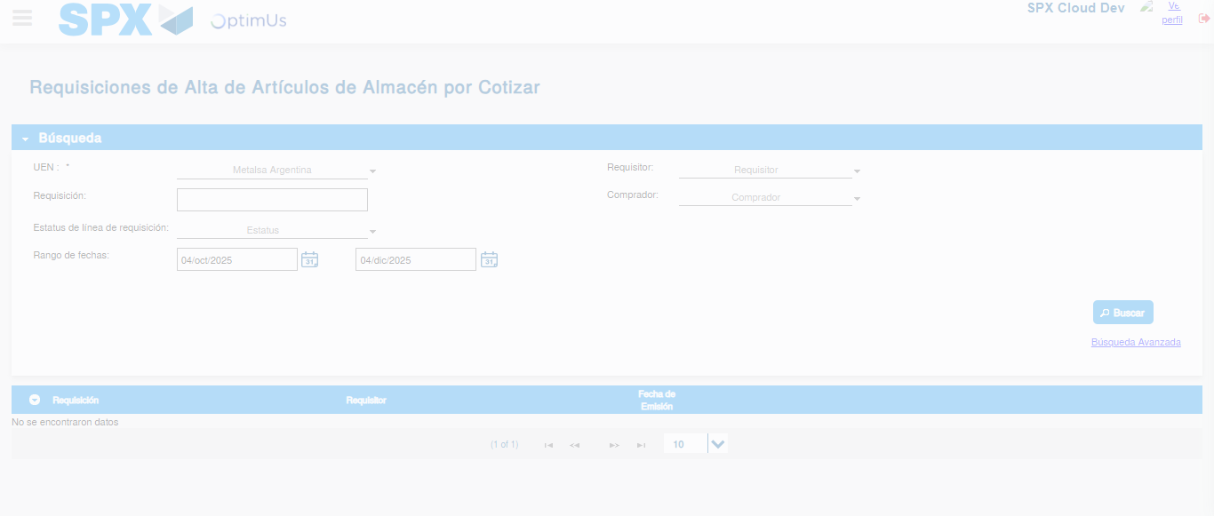Image file-name: QC_Testing-runTestMultipleTimes-dic. 04 2025, 04 00 47 p. m.

Image file-name: QC_Testing-runTestMultipleTimes-dic. 04 2025, 04 01 05 p. m.

Image file-name: QC_Testing-runTestMultipleTimes-dic. 04 2025, 04 01 06 p. m.

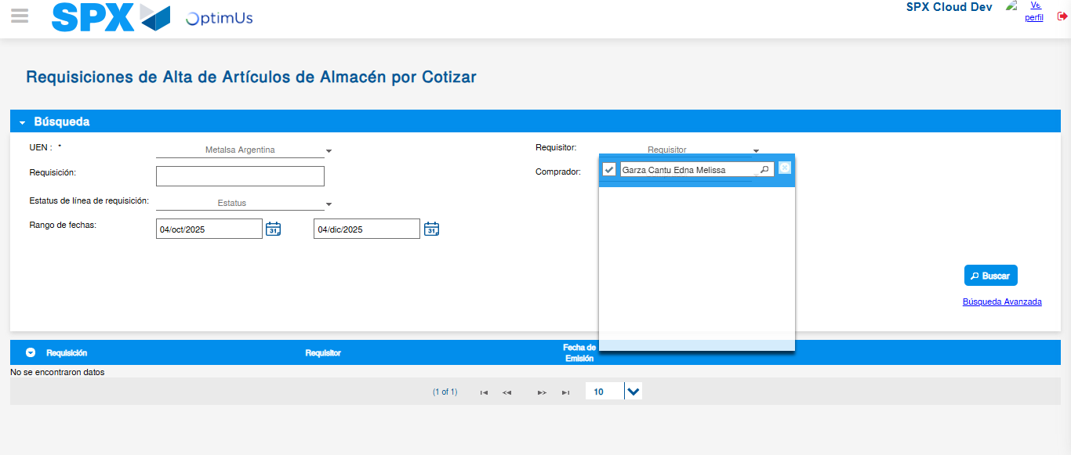Image file-name: QC_Testing-runTestMultipleTimes-dic. 04 2025, 04 01 32 p. m.

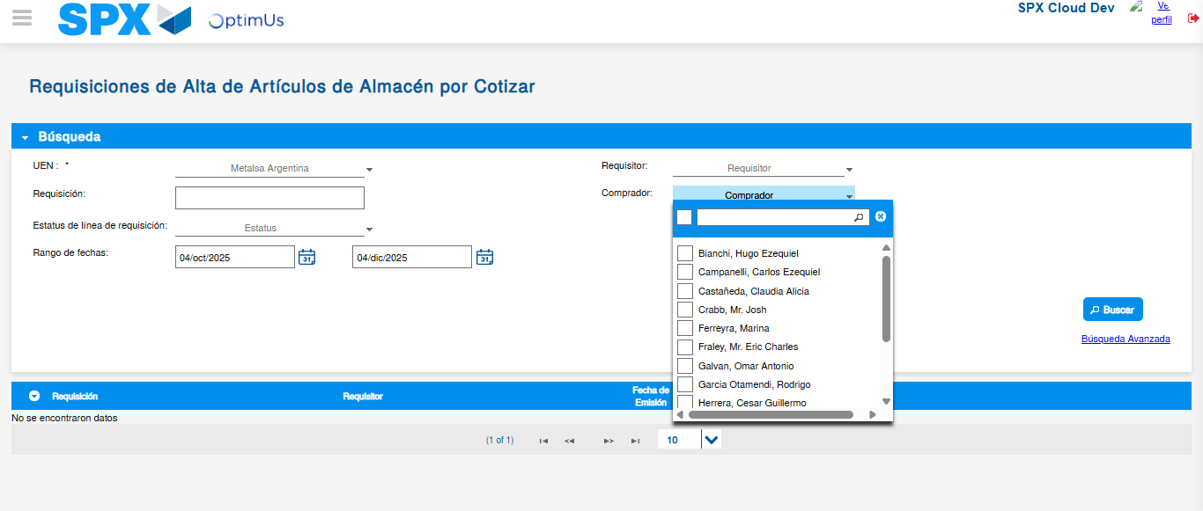Image file-name: QC_Testing-runTestMultipleTimes-dic. 04 2025, 04 01 35 p. m.

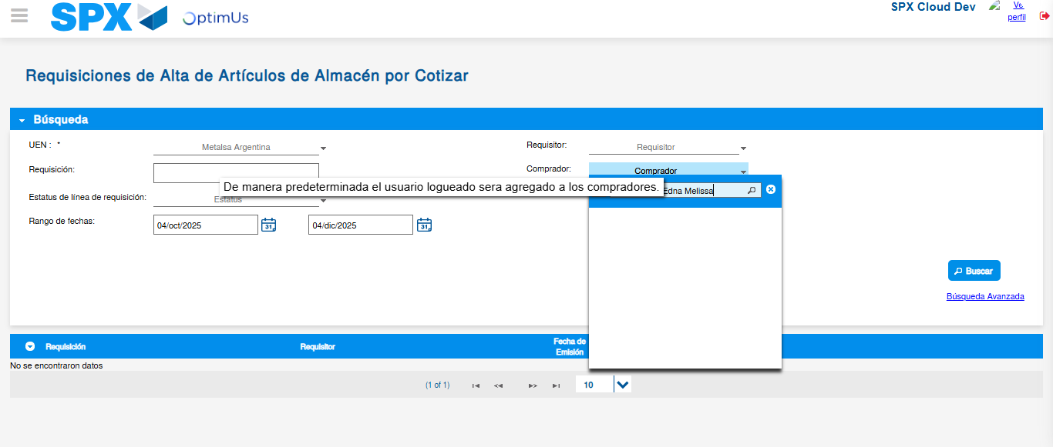Image file-name: QC_Testing-runTestMultipleTimes-dic. 04 2025, 04 01 36 p. m.

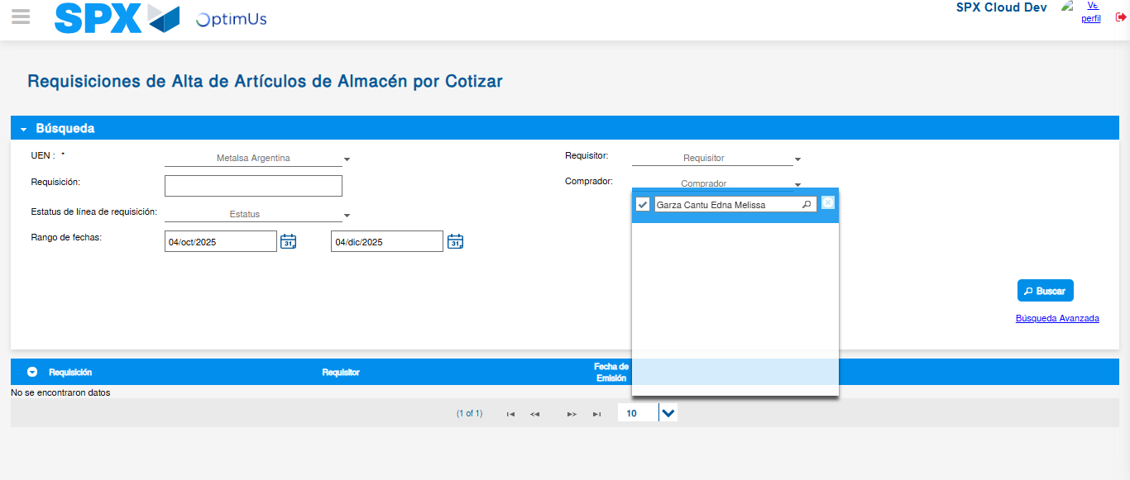Image file-name: QC_Testing-runTestMultipleTimes-dic. 04 2025, 04 02 01 p. m.

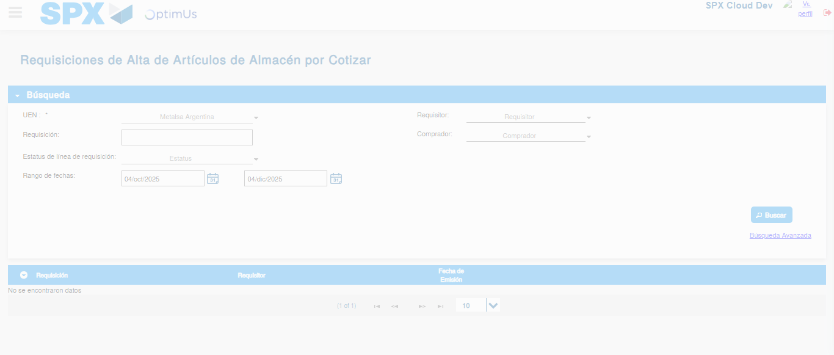Image file-name: QC_Testing-runTestMultipleTimes-dic. 04 2025, 04 02 05 p. m.

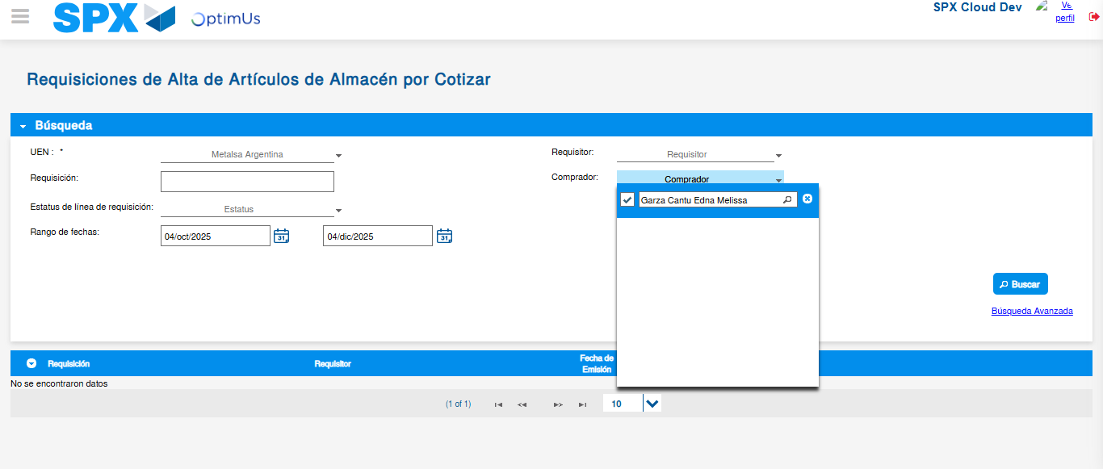Image file-name: QC_Testing-runTestMultipleTimes-dic. 04 2025, 04 02 23 p. m.

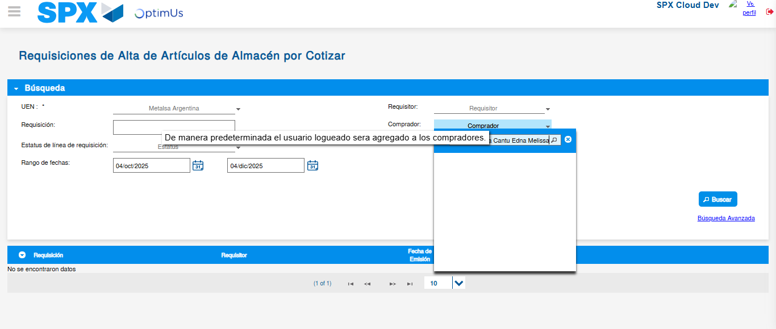Image file-name: QC_Testing-runTestMultipleTimes-dic. 04 2025, 04 02 24 p. m.

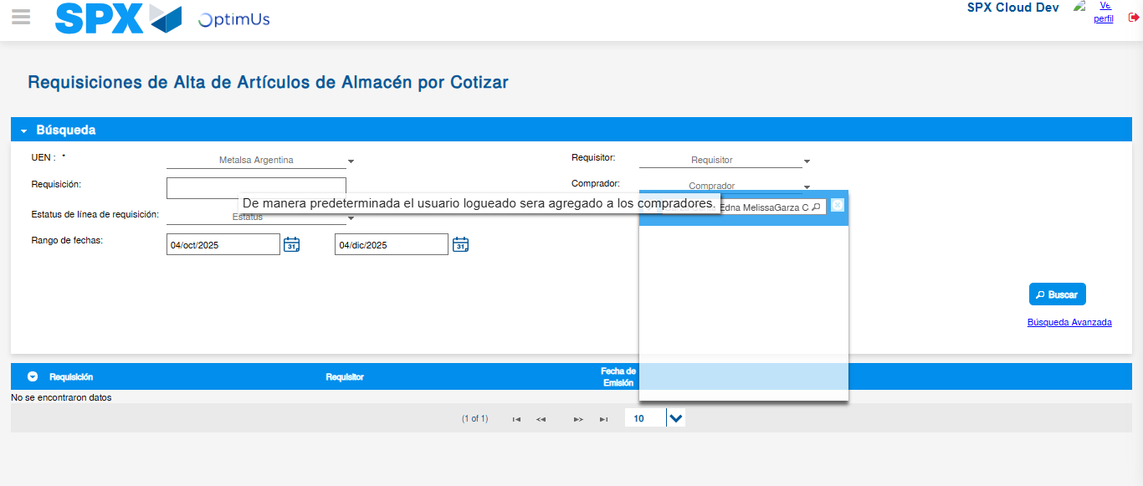Image file-name: QC_Testing-runTestMultipleTimes-dic. 04 2025, 04 02 50 p. m.

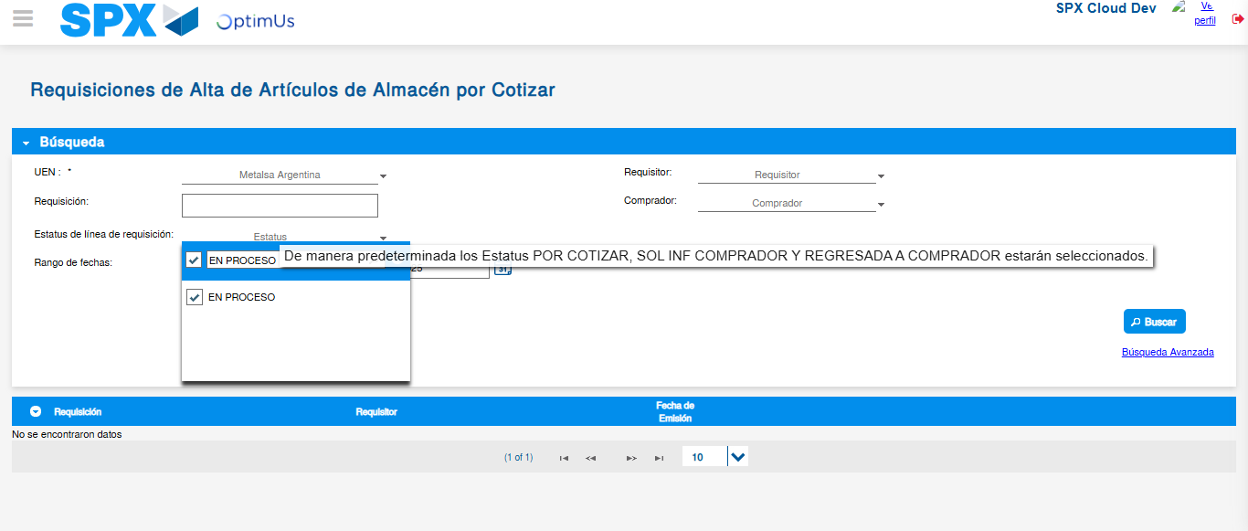Image file-name: QC_Testing-runTestMultipleTimes-dic. 04 2025, 04 02 53 p. m.

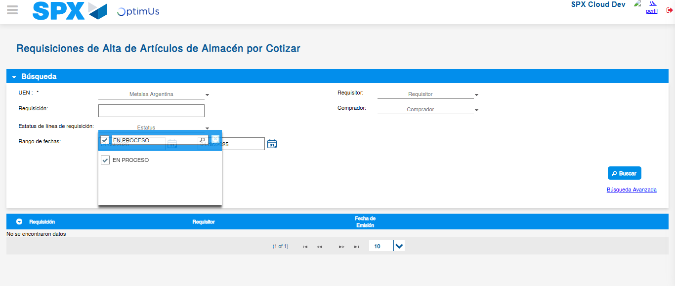Image file-name: QC_Testing-runTestMultipleTimes-dic. 04 2025, 04 02 54 p. m.

Image file-name: QC_Testing-runTestMultipleTimes-dic. 04 2025, 04 02 57 p. m.

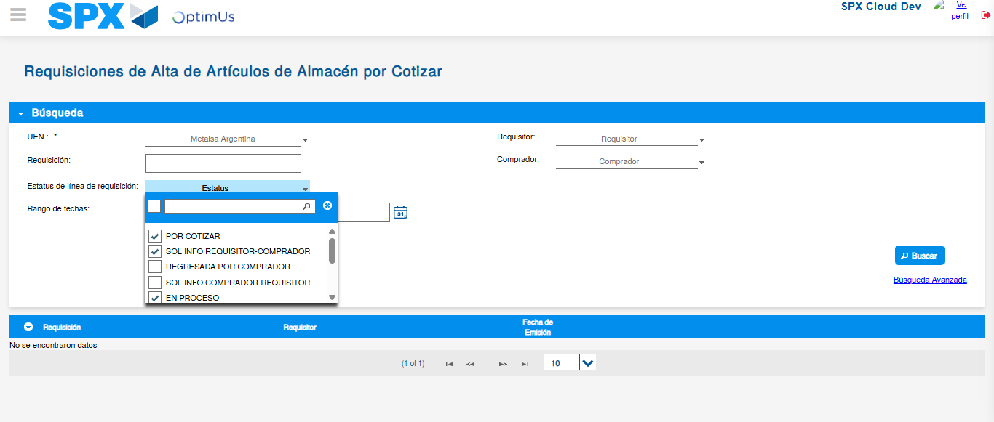Image file-name: QC_Testing-runTestMultipleTimes-dic. 04 2025, 04 03 15 p. m.

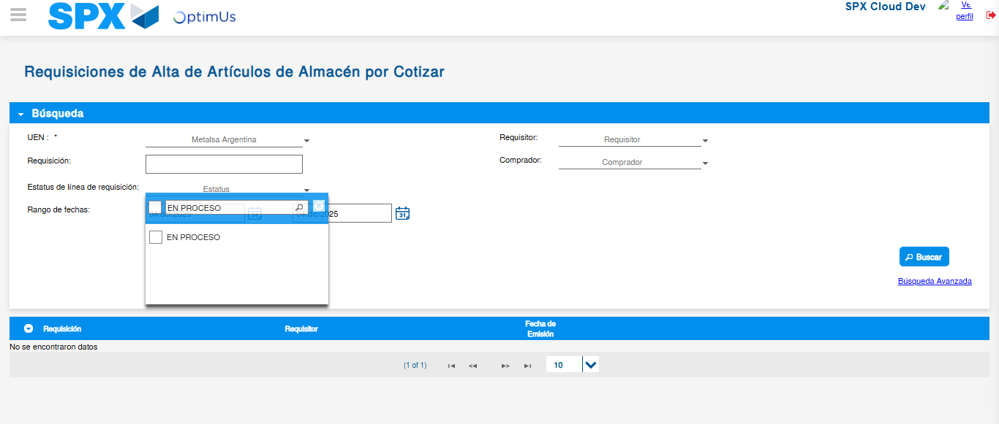Image file-name: QC_Testing-runTestMultipleTimes-dic. 04 2025, 04 03 16 p. m.

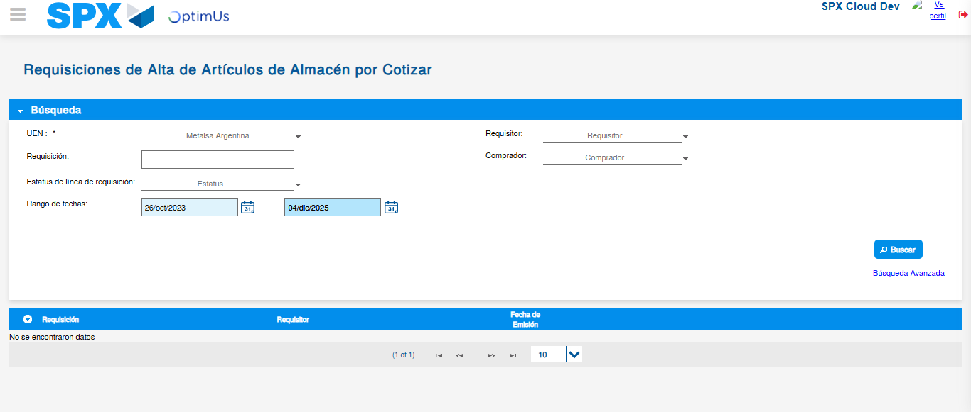Image file-name: QC_Testing-runTestMultipleTimes-dic. 04 2025, 04 03 20 p. m.

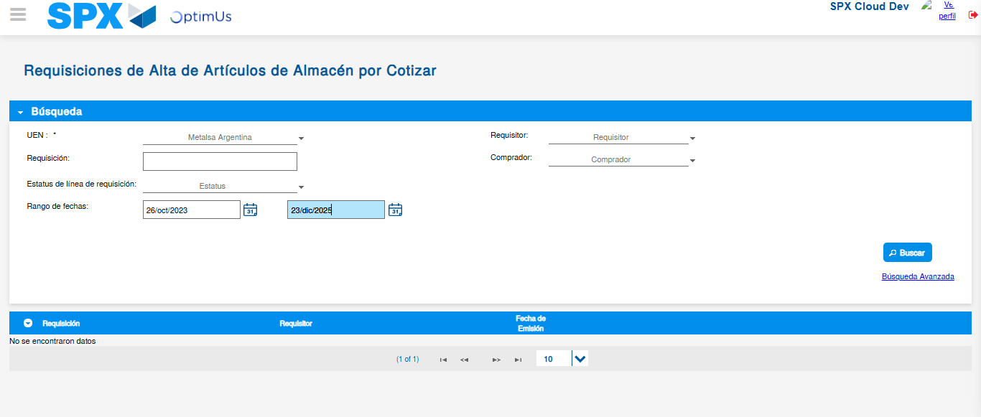Image file-name: QC_Testing-runTestMultipleTimes-dic. 04 2025, 04 03 23 p. m.

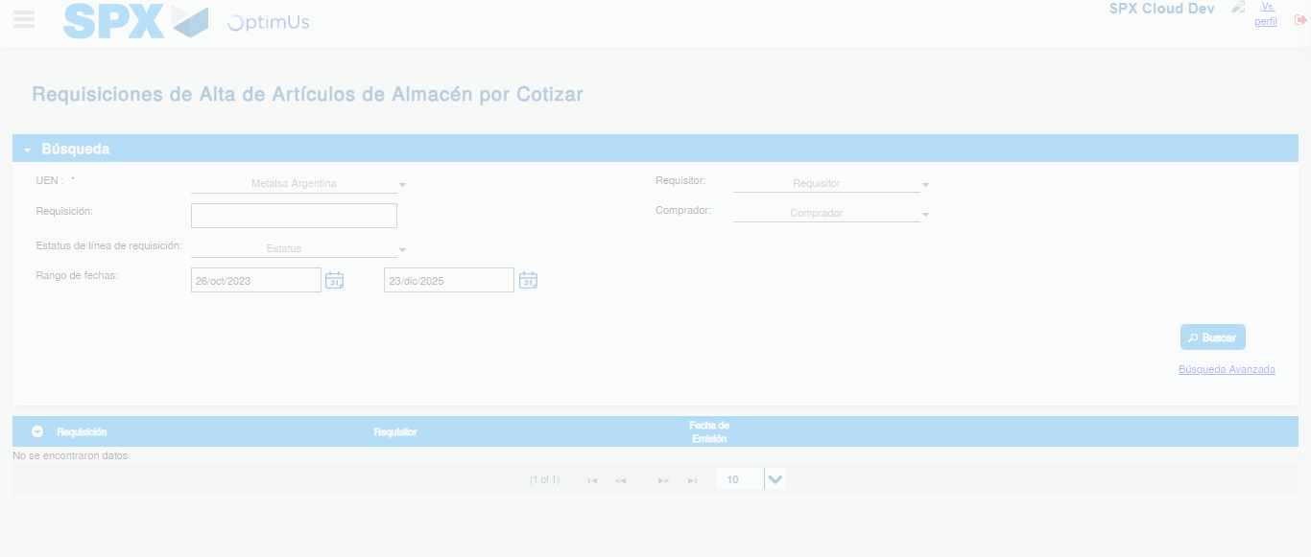Image file-name: QC_Testing-runTestMultipleTimes-dic. 04 2025, 04 03 27 p. m.

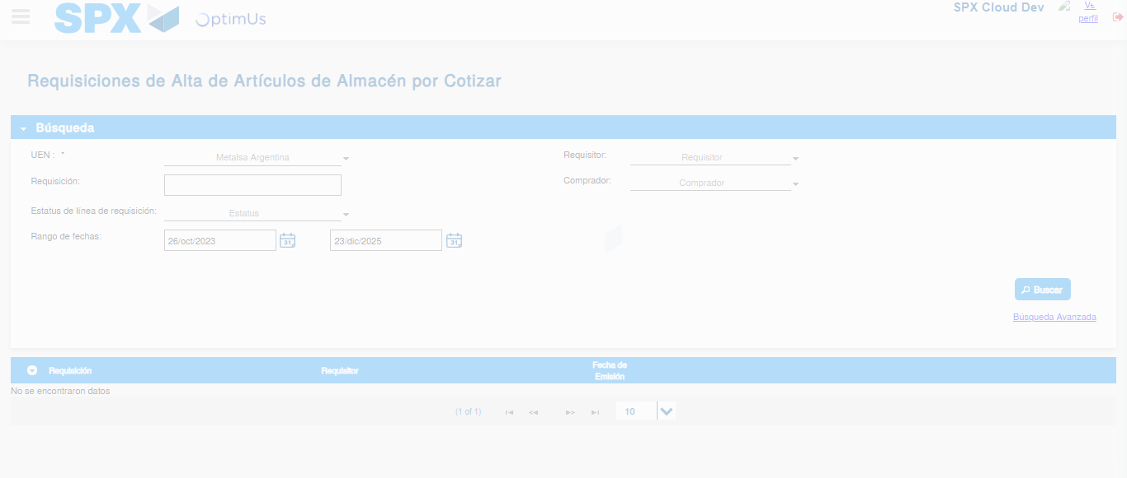Image file-name: QC_Testing-runTestMultipleTimes-dic. 04 2025, 04 03 45 p. m.

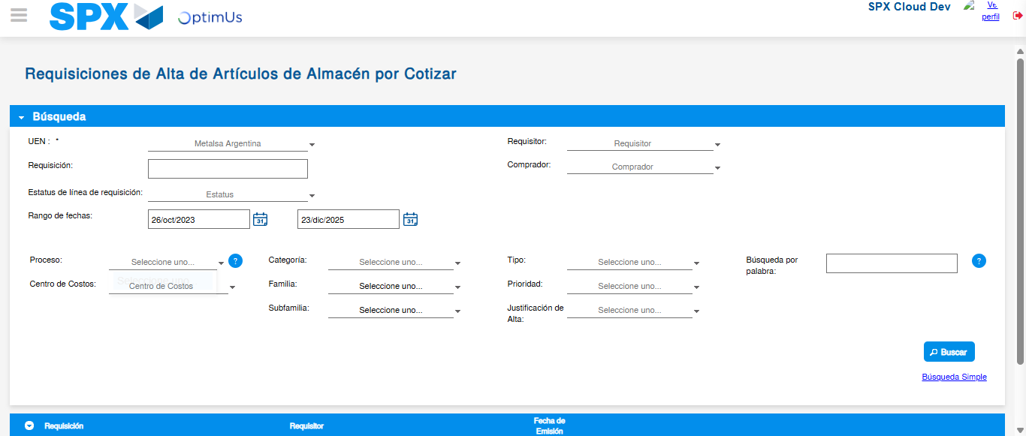Image file-name: QC_Testing-runTestMultipleTimes-dic. 04 2025, 04 03 46 p. m.

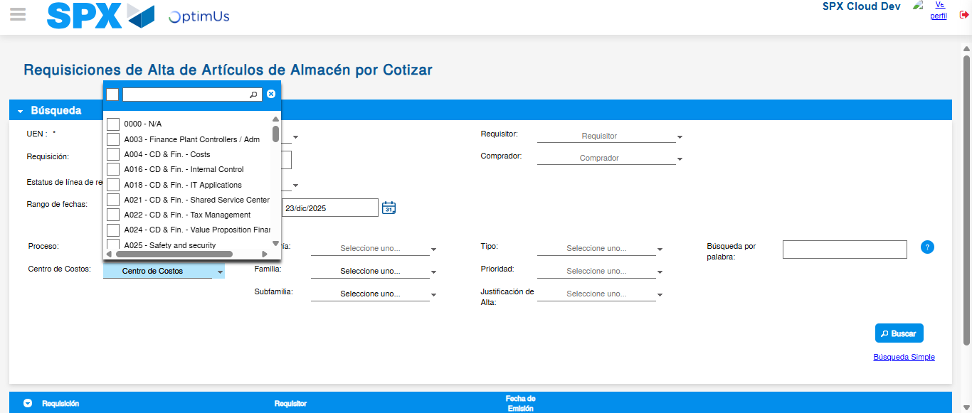Image file-name: QC_Testing-runTestMultipleTimes-dic. 04 2025, 04 03 47 p. m.

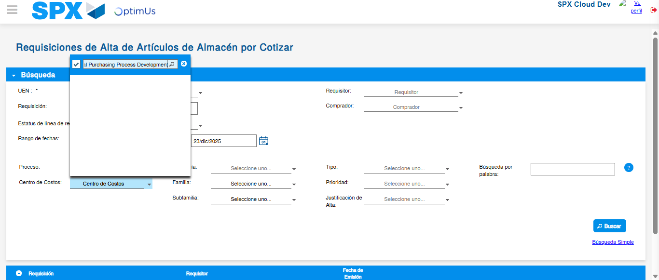Image file-name: QC_Testing-runTestMultipleTimes-dic. 04 2025, 04 03 48 p. m.

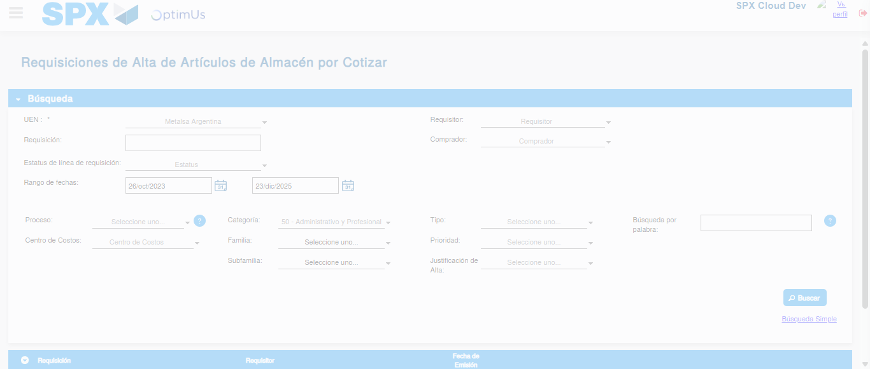Image file-name: QC_Testing-runTestMultipleTimes-dic. 04 2025, 04 04 20 p. m.

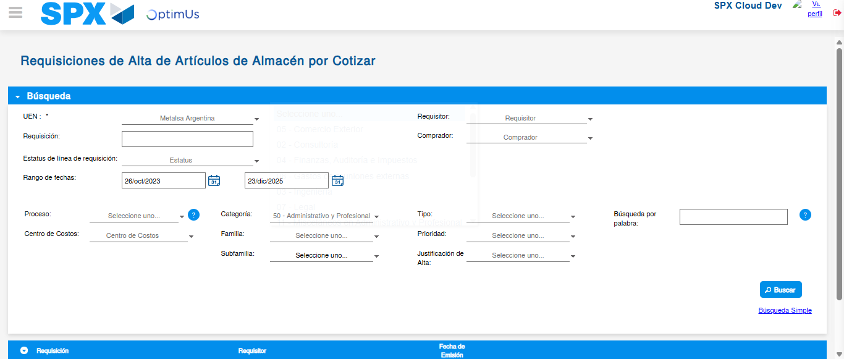Image file-name: QC_Testing-runTestMultipleTimes-dic. 04 2025, 04 04 23 p. m.

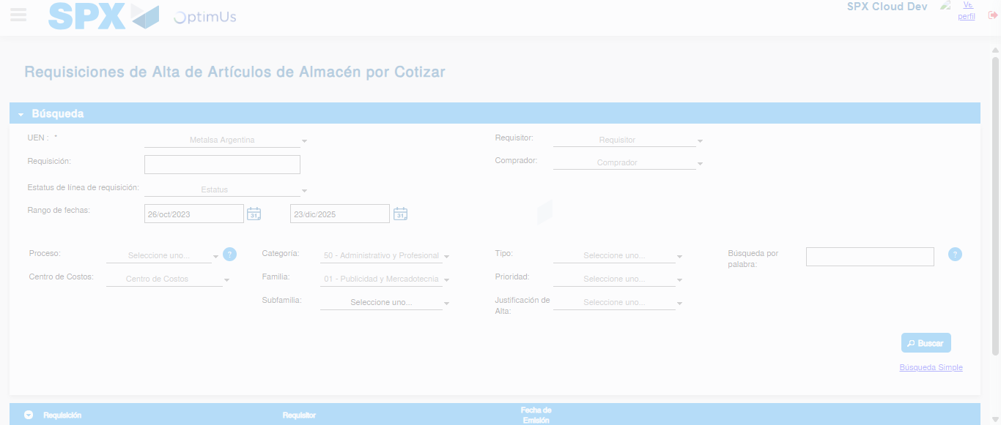Image file-name: QC_Testing-runTestMultipleTimes-dic. 04 2025, 04 04 24 p. m.

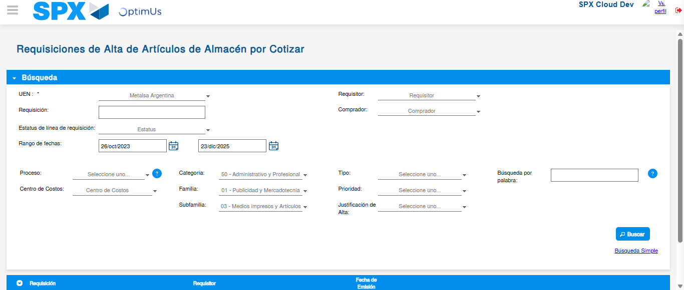Image file-name: QC_Testing-runTestMultipleTimes-dic. 04 2025, 04 04 27 p. m.

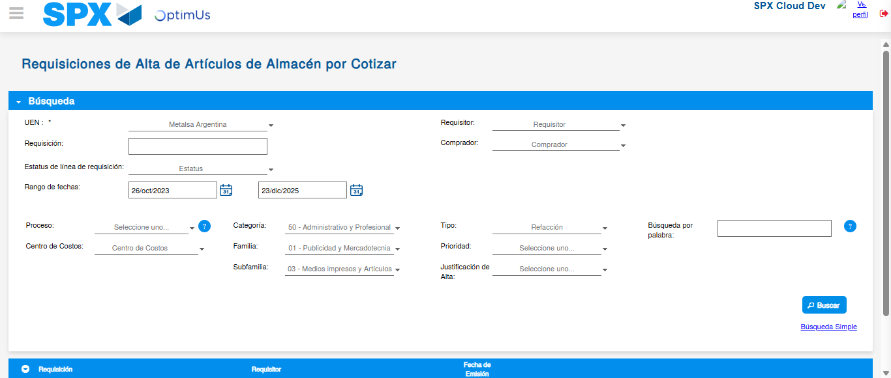Image file-name: QC_Testing-runTestMultipleTimes-dic. 04 2025, 04 04 31 p. m.

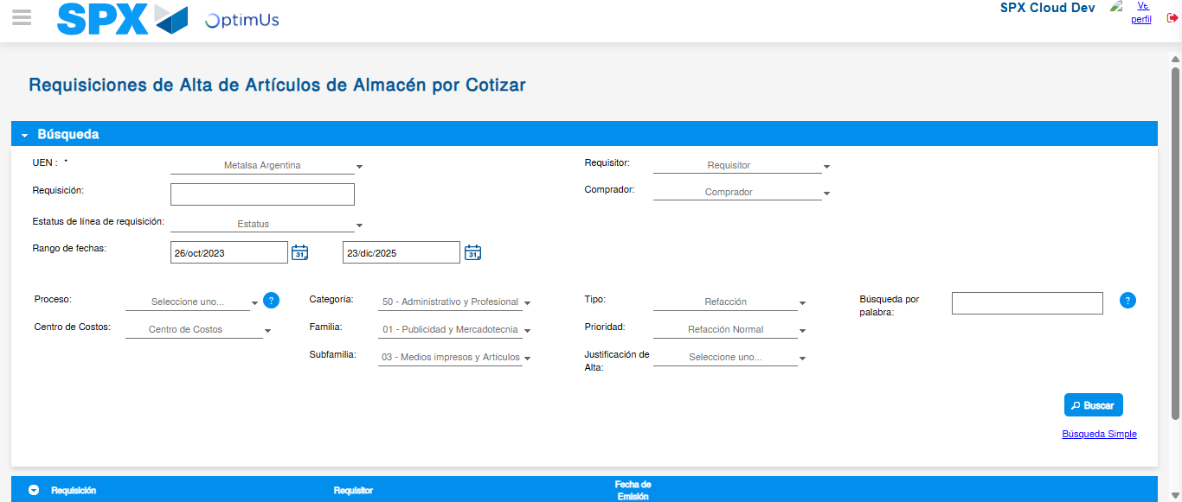Image file-name: QC_Testing-runTestMultipleTimes-dic. 04 2025, 04 04 34 p. m.

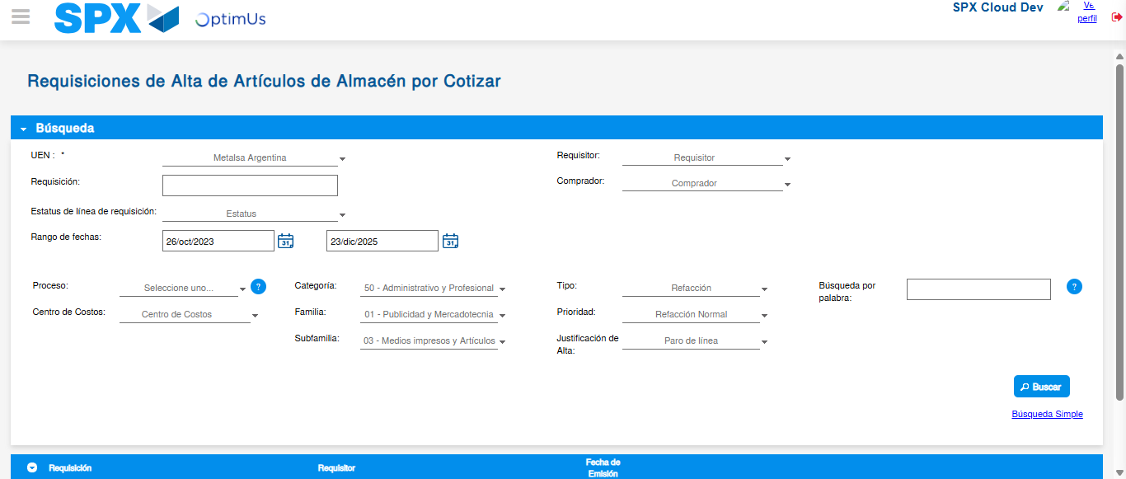Image file-name: QC_Testing-runTestMultipleTimes-dic. 04 2025, 04 04 38 p. m.

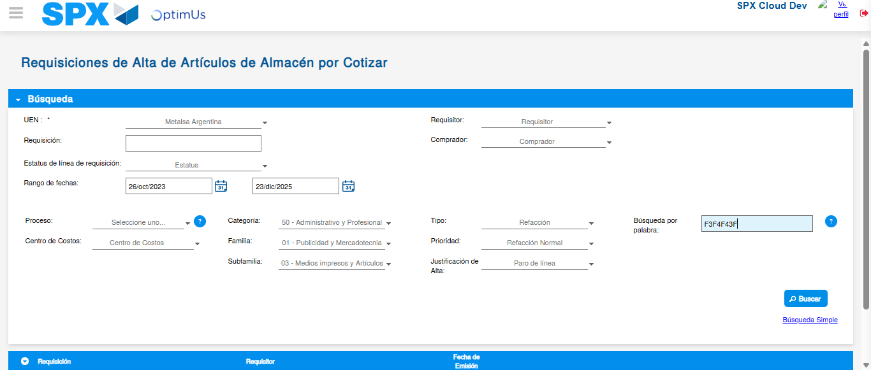Image file-name: QC_Testing-runTestMultipleTimes-dic. 04 2025, 04 04 41 p. m.

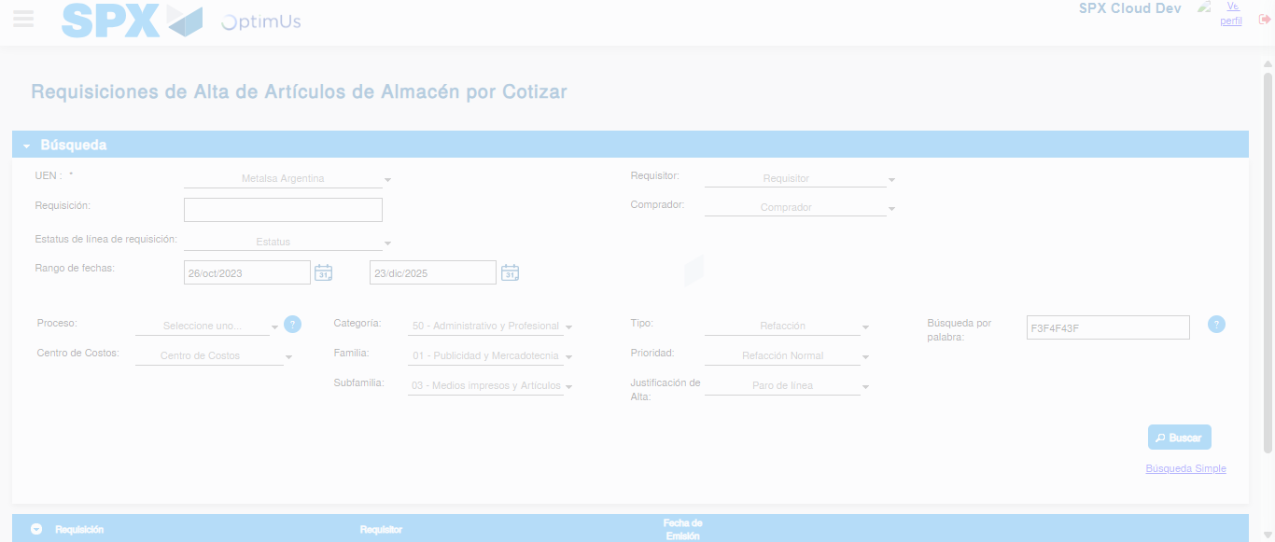Image file-name: QC_Testing-runTestMultipleTimes-dic. 04 2025, 04 04 45 p. m.

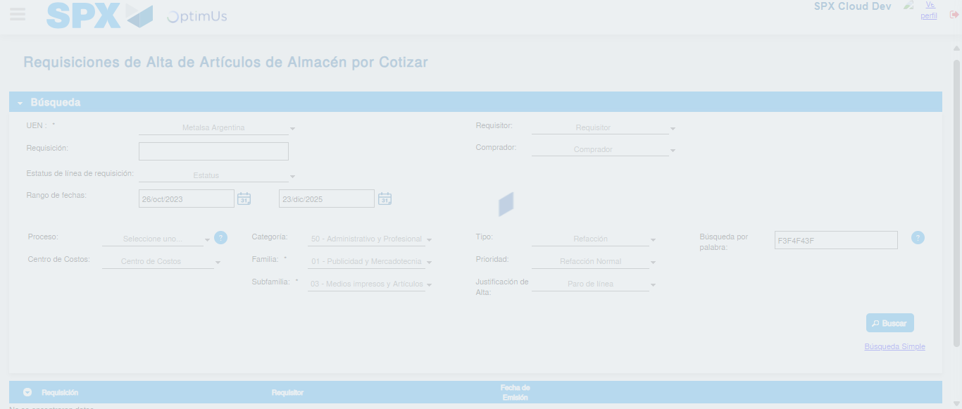Image file-name: QC_Testing-runTestMultipleTimes-dic. 04 2025, 04 05 03 p. m.

